**Tanner Wale**

**210 CYB Computer Networking**

**The Packet Tracer 5-2 Activity**

**1/30/23**

**Configure Static Routing**

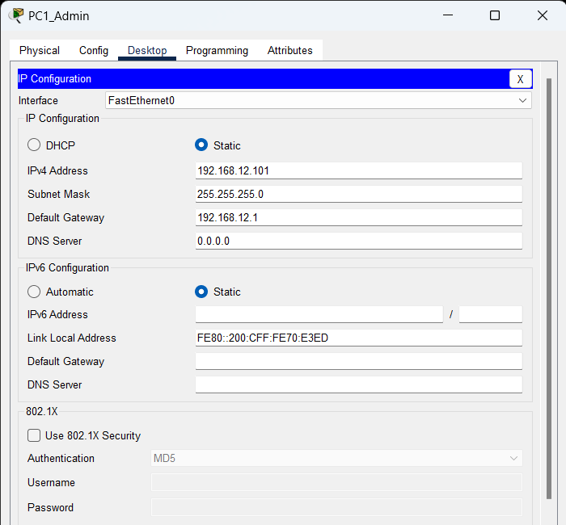

The way I configured the static routing was by accessing the admin network PCs and changing their IPv4 configuration to static then assigning them 192.168.12.101, 192.168.12.102, 192.168.12.103, and for the printer 192.168.12.150. Also, changing the default gateway from 192.168.6.1 to 192.168.12.1 with a subnet mask of 255.255.255.0.

**Configure RIP**

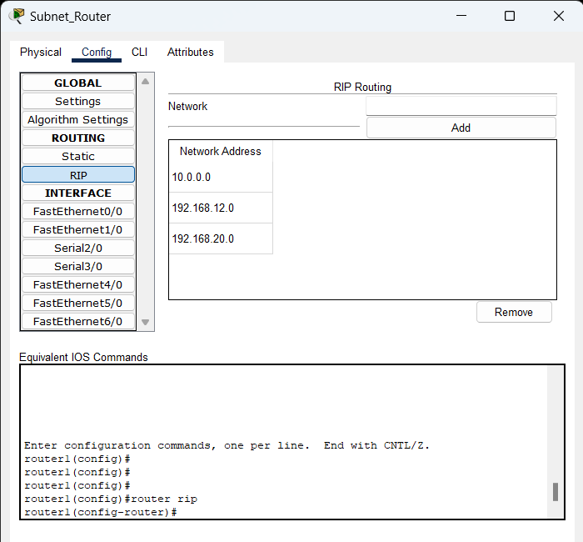

Configuring RIP is done by accessing the router and going to configuration tab RIP under ROUTING. After that add in 192.168.12.0 and 192.168.20.0 for the new network configuration of subnets. I did remove the 192.168.6.0 and 192.168.9.0 because these were the old RIP and would not be used anymore.

**Configure NAT**

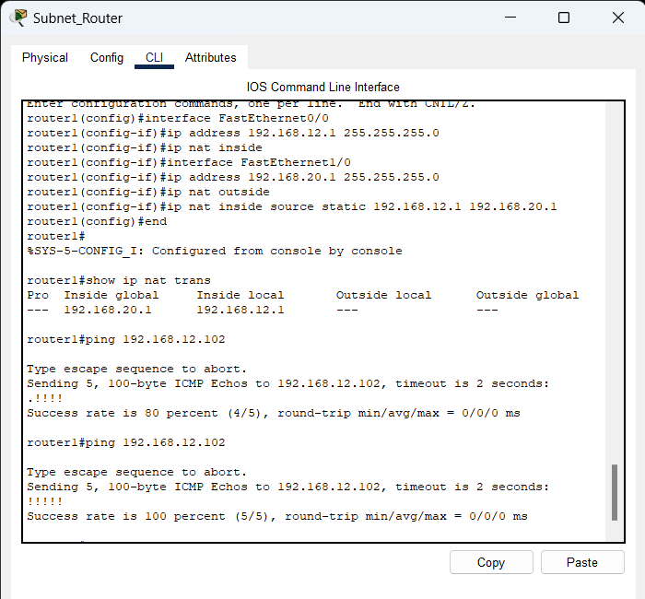

I configured the NAT by using the CLI on the router. I used the command interface FastEthernet0/0 to first select the admin network and make that the inside IP NAT. I assigned the ip address 192.168.12.1 to this interface and used the command ip nat inside to make it the inside ip nat. After that I used interface FastEthernet1/0 for the Student network and assigned the ip address 192.168.20.1 as the outside ip nat. I also added the subnet onto each one 255.255.255.0. Finally, we used the command ip nat inside source static 192.168.12.1 192.168.20.1 to make a map between the two ip addresses. Then we used the command show ip nat trans to show the NAT translations and used the ping command to ping a PC from the admin network to test that NAT is set to active.

**Configure DHCP**

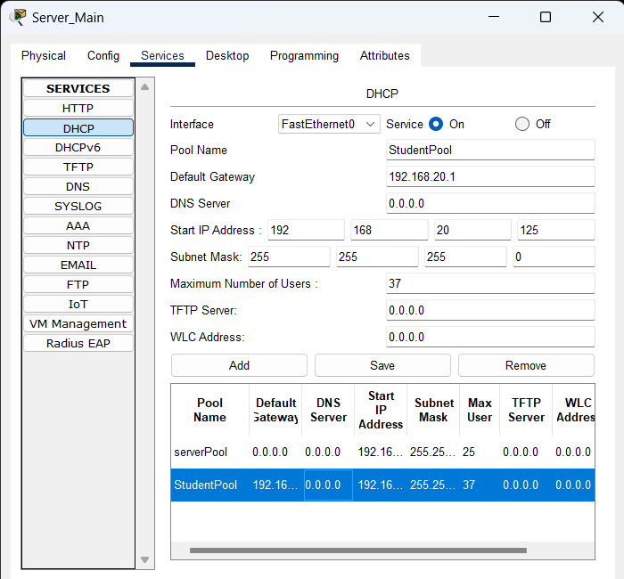

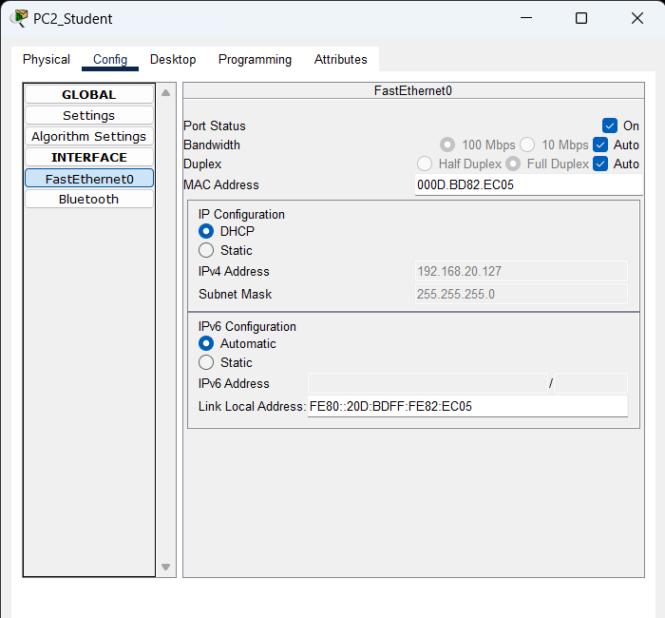

To configure DHCP on the server for the Student subnet I used the service of DHCP. I configured it to have 37 available IP addresses and the start of the IP address is 192.168.20.125. Also, the default gateway must be 192.168.20.1 to be on the same network. Finally on the PCs of the Student network I changed the static configuration to DHCP and dynamically the PCs and the printer converted to IPv4 addresses between 192.168.20.125 - 192.168.20.128. Also, I named the DHCP StudentPool and turned the service from off to on.

**Configure DNS**

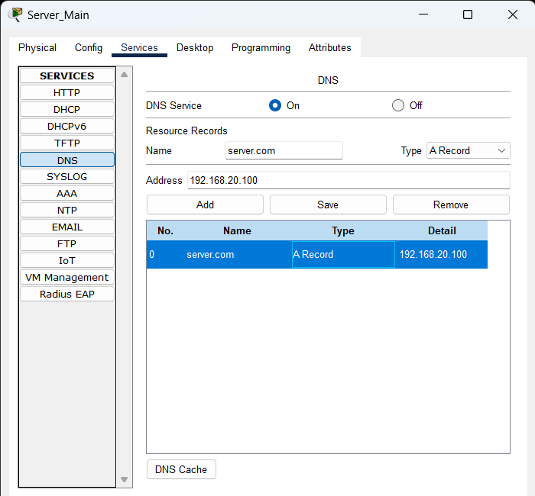

To configure the DNS server, we gave it the name of server.com and type would be A record because we want an IPv4 address. Also, give it an address of 192.168.20.100. Adding this to the DNS server was the final step.

**Label all devices and networks**

